**Step A**

1. **Introduction:**

The system is designed to store and manage data for a retail business. It includes information about customers, products, employees, suppliers, sales transactions, and inventory levels. The main functionalities of the system include managing sales transactions, tracking inventory levels, and maintaining records of customers, employees, and suppliers.

Entities and their functions:

* **Customers**: This entity stores information about the customers of the store, including their unique ID, name, and email address.
* **Employees**: This entity holds data about the store's employees, including their unique ID, name, position, and hire date.
* **Products**: This entity captures details about the products available in the store, including their unique ID, name, type, and price.
* **Suppliers**: This entity maintains information about the suppliers who provide products to the store, including their unique ID, name, and email address.
* **Inventory**: This entity tracks the stock of products in the store, including the unique inventory ID, quantity, last restocked date, product ID, and supplier ID.
* **Sales**: As a weak entity identified by CustomerID and EmployeeID, this entity records sales transactions, including the unique sale ID, date of sale, total amount, customer ID, and employee ID involved in the sale.

1. **ERD and DSD Diagrams:**

*ERD Diagram*

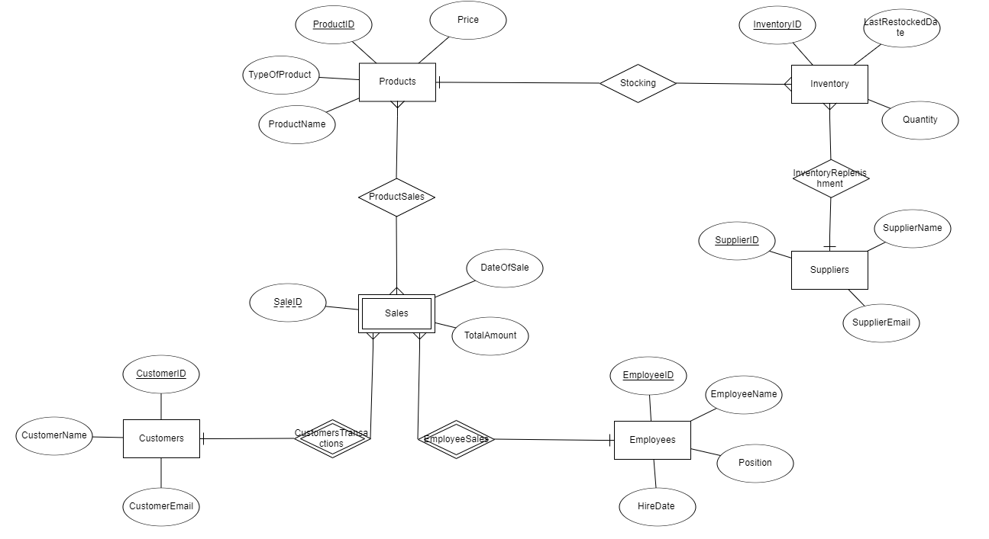

*DSD Diagram*

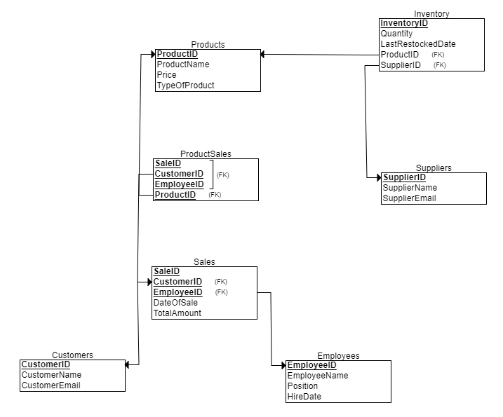

1. **Design decisions :**

Several design decisions were made to ensure the database structure meets the requirements:

* The Sales table is designed as a weak entity with identifying relationships to Customers and Employees.
* A many-to-many relationship between Products and Sales is implemented through the ProductSales table.
* Referential integrity is maintained with foreign key constraints.
* Data Types: INT was used for numeric fields, VARCHAR2 for text fields, and DATE for date fields, ensuring appropriate data representation and storage efficiency.

1. **SQL Commands :**

*- createTables.sql*

This script contains the SQL commands to create all the necessary tables for the database, including Customers, Employees, Products, Suppliers, Inventory, Sales, and ProductSales. Each table is defined with its respective columns and data types, and foreign key constraints are set to maintain data integrity and establish relationships between tables.

CREATE TABLE Products

(

ProductID INT NOT NULL,

ProductName VARCHAR2(100) NOT NULL,

Price INT NOT NULL,

TypeOfProduct VARCHAR2(100) NOT NULL,

PRIMARY KEY (ProductID)

);

CREATE TABLE Customers

(

CustomerID INT NOT NULL,

CustomerName VARCHAR2(100) NOT NULL,

CustomerEmail VARCHAR2(100) NOT NULL,

PRIMARY KEY (CustomerID)

);

CREATE TABLE Employees

(

EmployeeID INT NOT NULL,

EmployeeName VARCHAR2(100) NOT NULL,

Position VARCHAR2(100) NOT NULL,

HireDate DATE NOT NULL,

PRIMARY KEY (EmployeeID)

);

CREATE TABLE Suppliers

(

SupplierID INT NOT NULL,

SupplierName VARCHAR2(100) NOT NULL,

SupplierEmail VARCHAR2(100) NOT NULL,

PRIMARY KEY (SupplierID)

);

CREATE TABLE Sales

(

SaleID INT NOT NULL,

DateOfSale DATE NOT NULL,

TotalAmount INT NOT NULL,

CustomerID INT NOT NULL,

EmployeeID INT NOT NULL,

PRIMARY KEY (SaleID, CustomerID, EmployeeID),

FOREIGN KEY (CustomerID) REFERENCES Customers(CustomerID),

FOREIGN KEY (EmployeeID) REFERENCES Employees(EmployeeID)

);

CREATE TABLE Inventory

(

InventoryID INT NOT NULL,

Quantity INT NOT NULL,

LastRestockedDate DATE NOT NULL,

ProductID INT NOT NULL,

SupplierID INT NOT NULL,

PRIMARY KEY (InventoryID),

FOREIGN KEY (ProductID) REFERENCES Products(ProductID),

FOREIGN KEY (SupplierID) REFERENCES Suppliers(SupplierID)

);

*- dropTables.sql*

This script provides the SQL commands to drop all the tables created by the createTables.sql script. It ensures that tables are dropped in the correct order, taking into account the dependencies between them, and includes the CASCADE CONSTRAINTS option to handle foreign key constraints smoothly.

*- insertTables.sql*

This script includes SQL commands to insert data into each of the tables in the database. We provided sample data for Customers, Employees, Products, Suppliers, Inventory, Sales, and ProductSales tables to facilitate the testing and demonstration of the database's functionality.

*- selectAll.sql*

This script contains SQL commands to retrieve and display all data from each of the tables in the database. It is used to verify that the data has been correctly inserted and to provide an overview of the current state of the database.

1. **Data Entry Methods**

Method 1: Data Generator

We used the Data Generator tool in PL/SQL Developer to generate realistic data for each table.

*Screenshots*

Method 2: CSV Files

We used Mockaroo to generate CSV files for each table with 400 records.

*Screenshots*

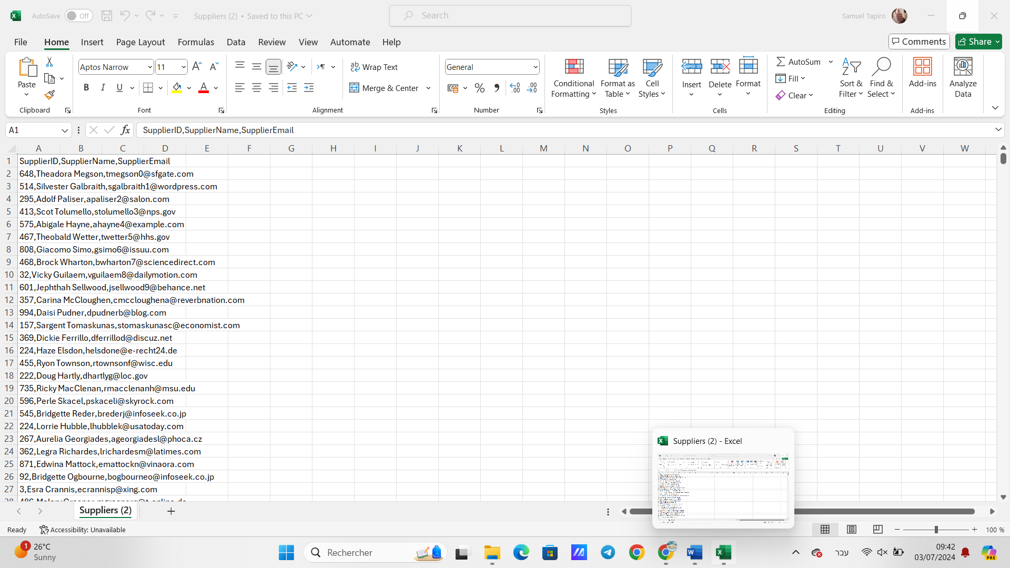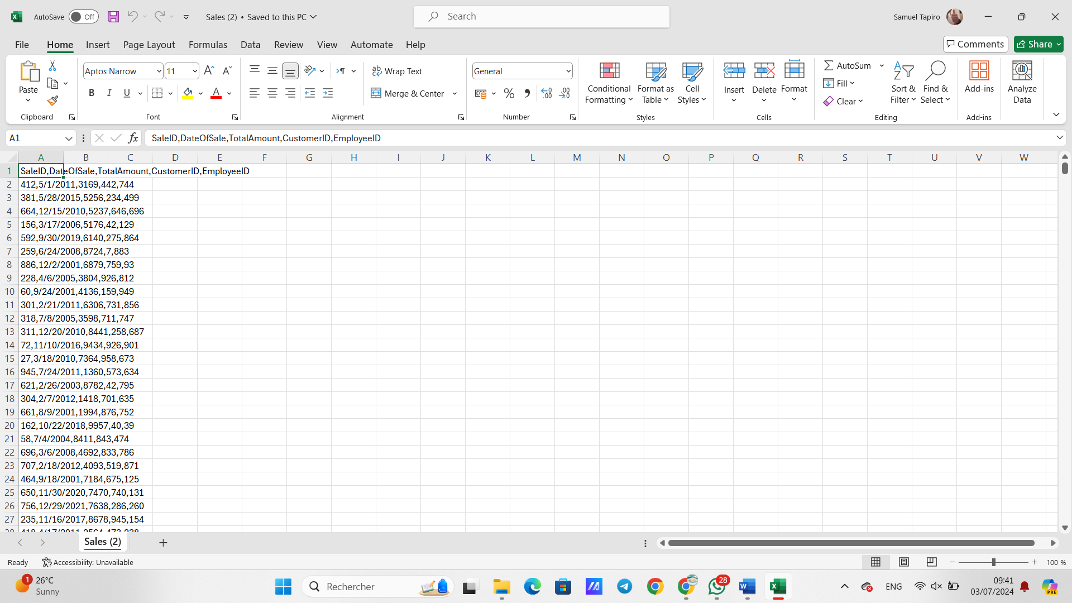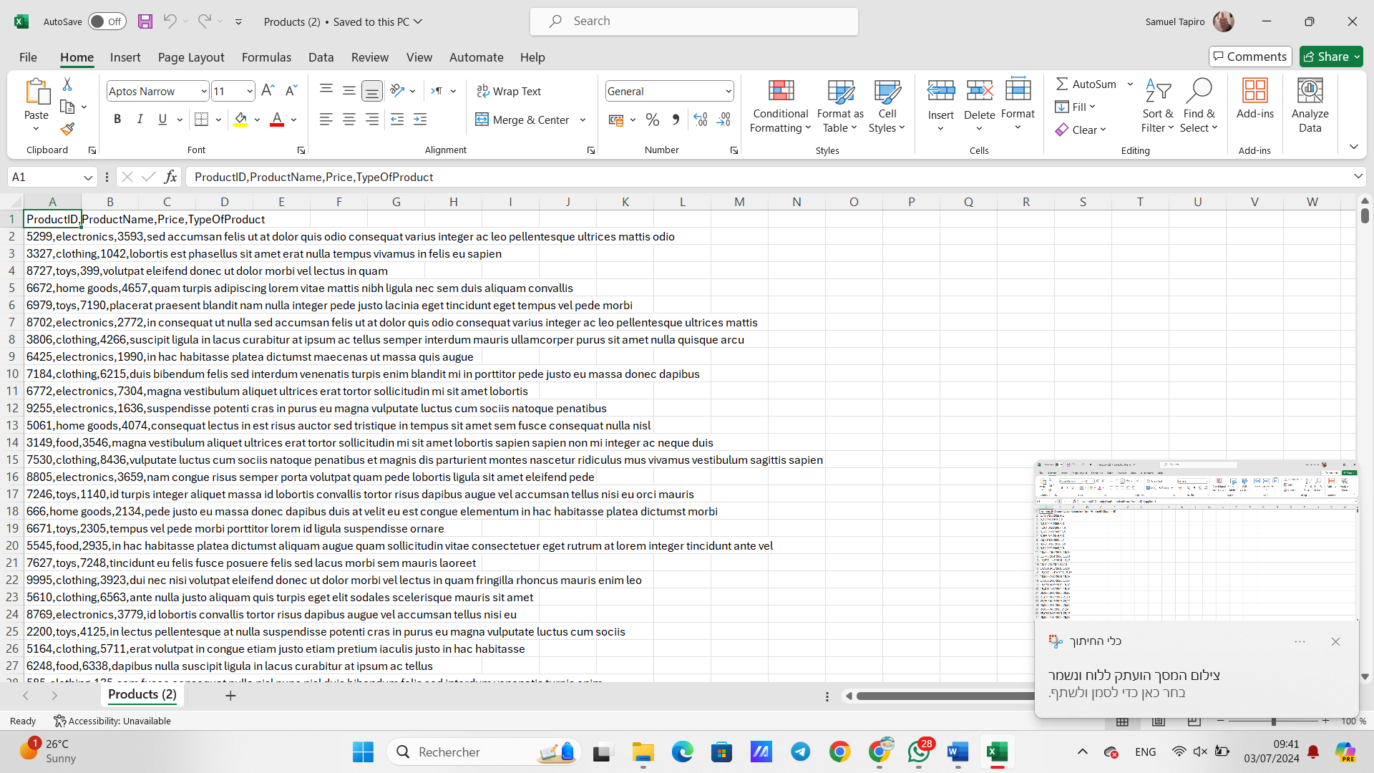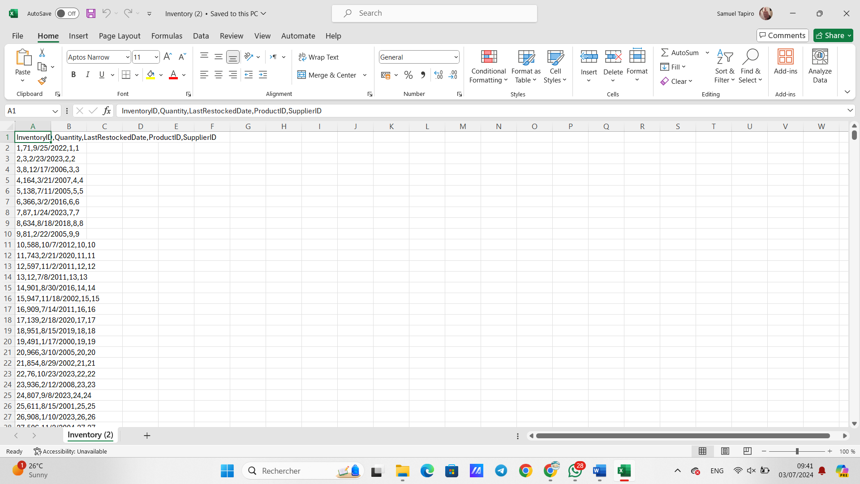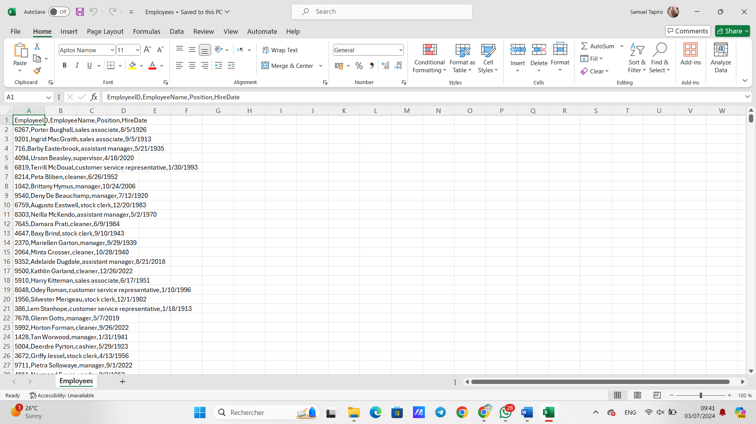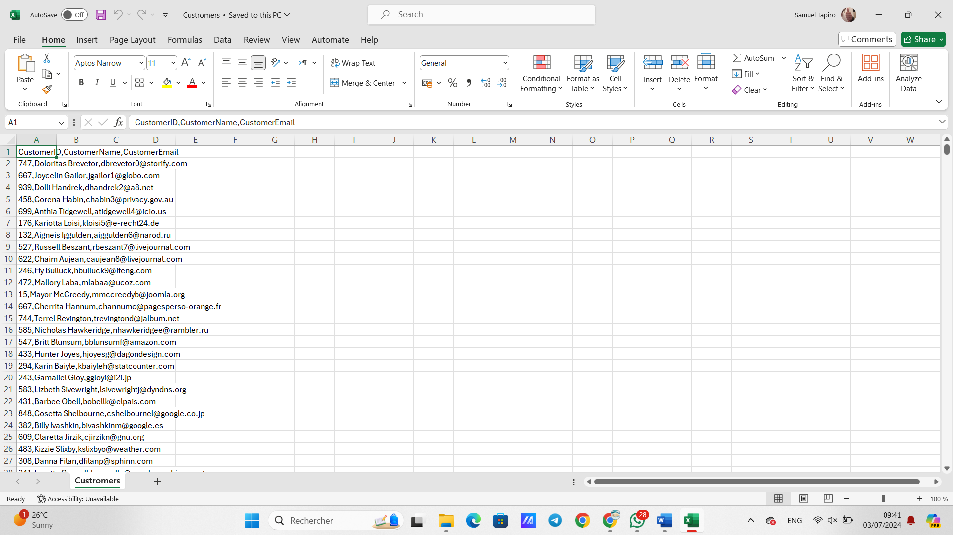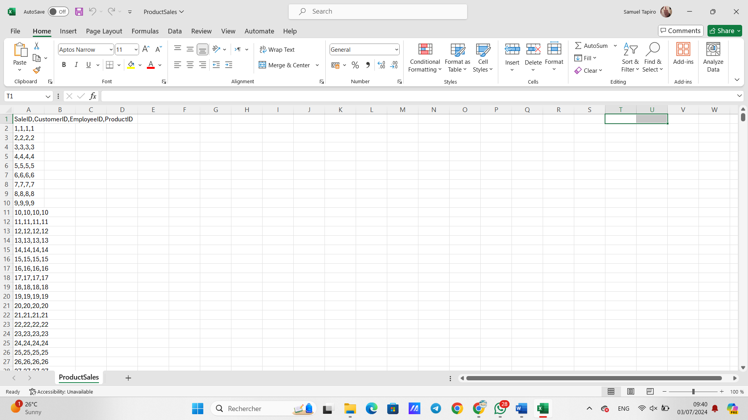

Method 3: Programming with Python

We created Python scripts to automate the data insertion process, leveraging the Faker library to generate realistic data (in Programming folder on the GitHub).

1. **Data Backup and Recovery**

Backup Process

We used PL/SQL Developer to create a backup of the database using the SQL Insert method, ensuring that CREATE TABLE commands were included.

*Screenshots*

